**Burndown:**

Take a screenshot of your team's Burndown Chart and submit it here.

**Evaluate and present how your individual contribution has impacted the progress of the project.**

This week I worked on the following tasks:

Make Dialogue box disappear when far enough away,

Remove collision with player and other blood diamonds.

**Indicate if you are behind, ahead, or on schedule for completion of the current milestone. Discuss what is impacting the schedule.**

I am on schedule so far. I could have done a lot more hours overall, but I made good progress.

**Work Log Hours:**

All students need to submit a weekly screenshot of their individual Production Plan in order to earn any points for their Sprint Logs.

**Work Log Instructions:**

***Task:*** The ID or name of the task you are documenting.

Make Dialogue box disappear when far enough away,

Remove collision with player and other blood diamonds.

***Work Description:*** A brief description of the work you completed for this task.

Make Dialogue box disappear when far enough away: What little progress that was reached was overshadowed by unintended behavior of message box that I was unable to fix. I still need more time to fix the solution.

Remove collision with player and other blood diamonds: I successfully removed the collision of blood diamonds when held by player. When the player releases the blood diamond, collision resumes. Collision is only with floor and switch, now not player.

***Screenshots / Video of Work:***

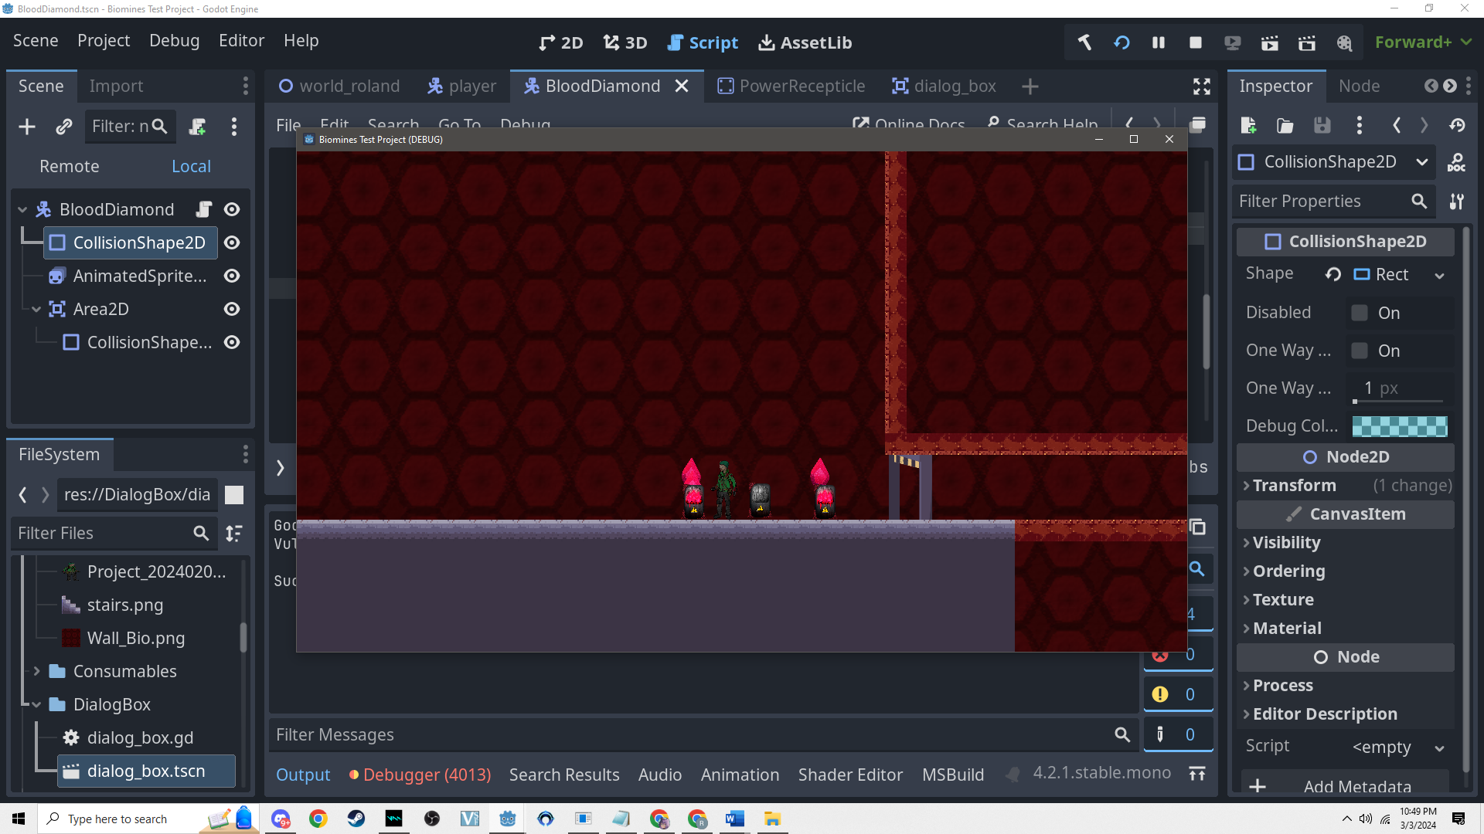

***Estimate:*** Estimated time for each task.

Make Dialogue box disappear when far enough away, 4 Hours

Remove collision with player and other blood diamonds. 4 Hours

***Daily Hours:*** Hours actually worked on for each task.

Make Dialogue box disappear when far enough away –

02/28/2024 - 7:41 PM - 9:27 PM

Remove collision with player and other blood diamonds

03/02/04 10:48 PM - 1:28 AM

2 Hours team building

**Stand Ups:**

***What have you accomplished since the last stand-up?***

Made Dialogue box disappear when far enough away,

Removed collision with player and other blood diamonds.

***What will you be working on until the next stand-up?***

make dialogue box disappear after player is a distance away .

***Do you have obstacles or anticipate issues that may slow you down? (or what obstacles did you overcome)***

I will not have any road blocks.

**Team Submission**

<https://youtu.be/HEWWVz9jWAM?si=jaIqTJeCpnDTq76X>

Time Stamp: 2:00